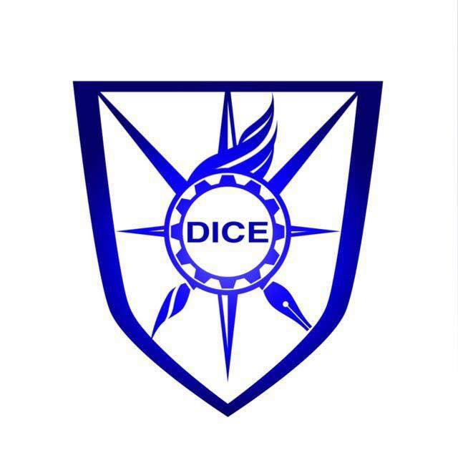
MNS University of Agriculture, Multan

DICE AFS 2022 Project Submission Form

The form must be filled/signed before uploading it as a pdf attachment at https://diceinnovationportal.com/Default.aspx

Applicant & Supervisor`s  Details | Project leader`s Full Name:
 | CNIC NO.:
 | Contact Number (Active WhatsApp):
 | Email address:
 | Postal Address for correspondence:
 | Name of Supervisor/Teacher:
 | Department:
 | Contact Number (Active WhatsApp):
 | Email Address (Mandatory):
 | Name of University/Institution:
 | Postal Address for correspondence:
Project Details | Tittle of the Project:
Domain
Select with * any of the following
- Food Sciences & Nutrition
- Crop, Soil & Environmental sciences
- Agribusiness, Economics & Entrepreneurship
- Agri engineering & mechanization
- IT and Computer Sciences (smart solutions)

No. of Participants who will accompany you at event (Including Supervisor):
Members:

Supervisor:

 | Description/ Rational of the Project:
Project details including materials & designs with complete adoption
(Please attach an extra page if required maximum 2 pages and also include images of models, designs and interactive interface):

Project Valuation (Rs.) | Please * check if the project is  - Concept  - Market ready for execution
Investment required to develop the project (for market ready projects):

Seed money for the refinement of concept (for concepts only):

Incubation Questions | Product of Project to be commercialized:
 | Significance of the Project/ targeted Audience:
Do you intend to adopt this idea as a professional business plan (yes/no):
If yes please provide answers to following questions.

 | What skills do you have that help you operate your project on a commercial scale:
 | Why would people buy your products and service:
 | How will you find these customers? What will you do to get them to buy from you?
 | If a new business, what steps have you taken to start your business?
 | If you have already started, what are some of the challenges you have faced?
 | What steps have you taken to rectify these challenges?
Declaration by applicant

I, the undersigned, duly understand, affirm and certify that:
- I am fully authorized to represent my project and/or business associates on its/their behalf.
- I am completely aware of the applicable terms and conditions in applying to DICE AFS 2021.
- I have submitted the project/innovation plan with the application for utilization of the services of DICE AFS 2021
- I shall submit all required documents and cooperate with DICE AFS in every respect.

DICE AFS 2021 reserves the right to accept or reject any application, at any stage. The decision to my/our application will be final and incontestable and applicant will not appeal against the decision.

The information provided in this application is correct to the best of my knowledge & belief.
Name | Designation/ status | CNIC
Signature |  | Dated:

